**BUSINESS REPORT**

**ON**

**FINANCIAL RISK ANALYSIS**

**TOPIC - CREDIT CARD RISK**

**NAME – R INDUJA**

**PGP-DSBA|ONLINE**

**INTRODUCTION**

Dependent variable - We need to create a default variable which should take the value of 1 when net worth next year is negative & 0 when net worth next year is positive.

Validation Dataset - We need to build the model on train dataset and check the model performance measures on validation dataset.

SOLUTION - Financial risk analysis is the assessment of the likelihood of a threat occurring and its possible impact. Hence, its importance in risk management. Financial risk management is the calculation of the potential effect of a risk and its degree of exposure.

Here we will see credit card risk analysis,

**Credit default prediction allows lenders to optimize lending decisions, and minimize risk and exposure, which leads to a better customer experience and sound business economics**

We will start with importing libraries for data.

import numpy as np

import matplotlib.pyplot as plt

import pandas as pd

import seaborn as sns # for making plots with seaborn

color = sns.color_palette()

import sklearn.metrics as metrics

import warnings

warnings.filterwarnings("ignore")

Libraries have been imported successfully, and now we can see the data that we have loaded :-

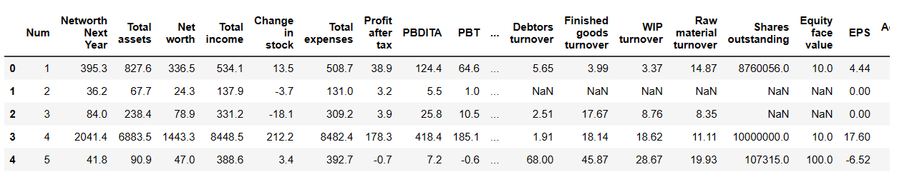

The number of rows (observations) is 4256

The number of columns (variables) is 51

Now, let us check the basic measures of descriptive statistics for the continuous variables

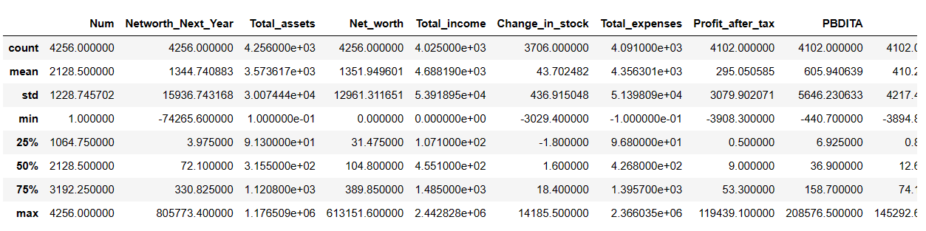

Above mentioned summary has the mean, median, mode, 1st ,2nd and 3rd quadrant values of the relevant data set.

**Creating a binary target variable using 'Networth_Next_Year'**

Company['default'] = np.where((Company['Networth_Next_Year'] > 0), 0, 1)

Company[['default','Networth_Next_Year']].head(10)

**[Company['default'] = np.where((Company['Networth_Next_Year'] > 0), 0, 1)]**

We have created the binary target variable using the above formula and the results:

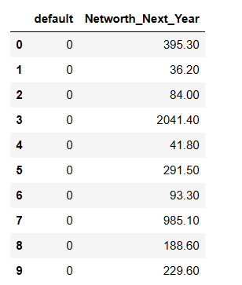

Imputed default column in data set, 0 reflectes the positive value in dataset and 1 indicates the negative value in data set.

0 3352

1 904

Name: default, dtype: int64

**Solution**: we have total 3352 positive values and 904 negative values in data set.

## Let’s check for missing values in the dataset

Null values - Null values, often referred to as missing values, represent the absence of data in a dataset. In Python, these values are typically represented as **None** or **NaN** (Not a Number).

Null values can impact data analysis and modeling in negative ways, such as biasing statistics or affecting the performance of machine learning algorithms. Therefore, it's essential to carefully consider how to deal with null values, whether by removing, imputing (filling in), or flagging them, depending on the nature of the data and the analysis goals

**Solution:** we will impute null values using KNN IMPUTERS mentioned bellow:

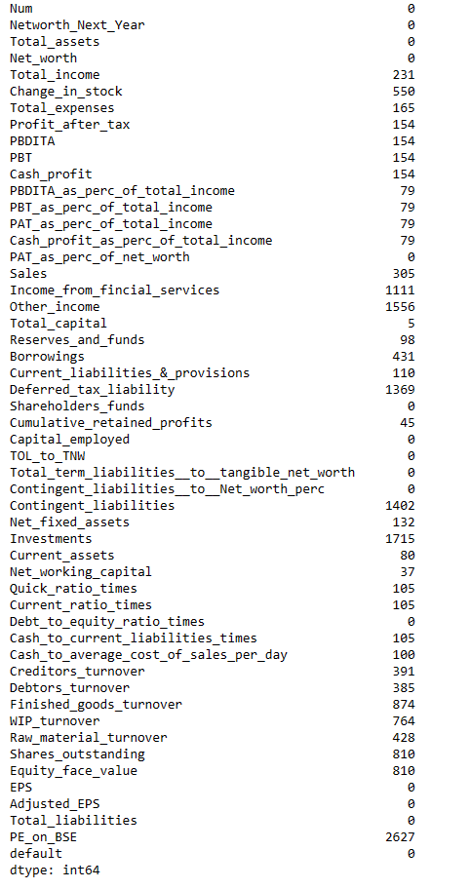

We can see the columns with null values.

Total: **17778 null values in data set we will use, KNN imputers to eliminate null values**

KNNImputer: The K-Nearest Neighbors (KNN) Imputer is a data imputation technique used to fill in missing values in a dataset by using the values of neighboring data points. It's a machine learning-based approach that leverages the concept of similarity between data points to estimate and replace missing values. KNN imputation is particularly useful when missing values are related to the values of nearby data points.

**Formula:**

from sklearn.impute import KNNImputer

imputer = KNNImputer(n_neighbors=10)

Company_imputed = pd.DataFrame(imputer.fit_transform(Company_sub3), columns = Company_sub3.columns)

Company_imputed.isnull().sum()

RESULT :

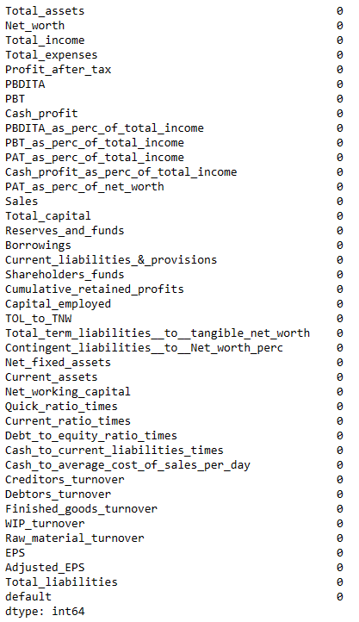

Null values have been eliminated from the data.

**Correlation heatmaps**: Correlation heatmaps are a type of plot that visualize the strength of relationships between numerical variables. Correlation plots are used to understand which variables are related to each other and the strength of this relationship.

#### Inspect possible correlations between independent variables

#### 

We can see the dependent variable in the data set

Net worth is higher in percentage with higher total assets.

#### Validating the model on train and test set

#### Test and Train Data: It is called Train/Test because you split the data set into two sets: a training set and a testing set. 80% for training, and 20% for testing. You train the model using the training set. You test the model using the testing set.

**Train results:**

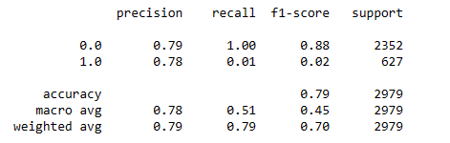

**Result:** For zero train value for F1 – 0.88 and for 1 train value is F1 – 0.02.

**Test results:**

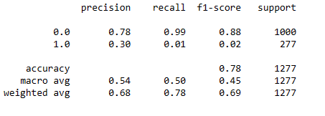

**Result:** For zero test value for F1 – 0.88 and for 1 test value is F1 – 0.02.

Since we can see that only 7% of the total data had defaults.

Summary

**Importance of Credit card default**

Defaulting on your credit card payment can have several consequences, including late payment fees, interest charges, a negative impact on your credit score, legal action, debt collection agencies, and loss of credit card benefits.

**Prevention from Credit card default:**

**Credit Counseling and Education:** Offer credit counseling and financial education programs to customers at risk of default. Help them better manage their finances and debts.

**Customized Payment Plans:** Provide flexible payment options for customers facing temporary financial difficulties. Tailored payment plans can reduce the likelihood of default.

**Fraud Detection and Prevention:** Strengthen fraud detection mechanisms to

prevent unauthorized credit card usage, which can contribute to defaults.

**Credit Scoring Improvement:** Enhance the credit scoring model by incorporating more relevant variables or utilizing

Continuously monitor and validate the model's performance to ensure it predicts default accurately.

**Collection Strategies:** Develop effective and ethical collection strategies for recovering overdue payments without damaging customer relationships.

THANK YOU